Job Title: Village Engineer (Community Development)
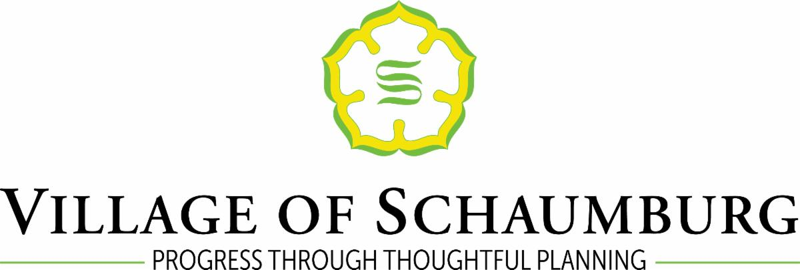

VILLAGE OF SCHAUMBURG
Human Resources Department
101 Schaumburg Court, Schaumburg, IL 60193

Please apply online at http://www.schaumburg.com/

The Village of Schaumburg is a thriving community of 78,732 residents located 12 miles west of O’Hare International Airport and approximately 26 miles northwest of Chicago. Not only is Schaumburg the twelfth-largest community in the State of Illinois, but it is also home to the second-largest concentration of retail, office, and commercial activity. Notable village distinctions include being named one of the "Top Ten Best Places to Live" by Money Magazine; being ranked No. 5 overall in WalletHub's "Best Illinois Cities for Jobs"; and receiving the Distinguished Budget Presentation Award from the Government Finance Officers Association for meeting the highest principles of governmental budgeting for the seventh consecutive year.

The village employs approximately 600 employees in 12 departments, including police, fire, engineering and public works, communications, community development, cultural services, economic development, finance, general government, human resources, information technology, and transportation. Our employees work to serve the residents and strive to make Schaumburg the best community it can be.

NOW ACCEPTING APPLICATIONS FOR THE POSITION OF:
Village Engineer (Community Development)
Interested candidates are encouraged to apply as soon as possible. Interviews will be conducted as applications are received. This position will remain open until filled.

STARTING SALARY RANGE: $92,462.00 - $123,679.00 annually dependent on qualifications. The salary range for this position is $92,462.00 - $134,084.00

Please attach as part of your application all necessary documents verifying that you meet the minimum qualifications for the position.

JOB SUMMARY:
This position is responsible for regulation of private land development within the village, including supervision of the engineering work group. The position also manages contracts related to consulting engineering services. Responsibilities include participation in the Project Review Group multi-department development review process; evaluating development proposals to ensure compliance with applicable codes and ordinances; providing technical advice to boards and commissions on subdivision and development engineering related items; and performing other duties of considerable difficulty involving regulatory engineering issues and functions. May serve as Village Engineer as determined and appointed by the Village Manager. Position is a middle management position within the department requiring strong supervisory skills, public contact, and the ability to exercise good judgment and work independently. The position may have responsibility for project management of Capital Improvement Projects.

To succeed in this role, applicants will need to effectively and clearly communicate to a full range of people, be able to work cooperatively and effectively with others to achieve common goals, and develop and implement new process, service, or strategy with the aim of improving efficiency or effectiveness. We are looking to add a team member with a strong work ethic and knowledge of engineering regulations and rules.

May be eligible for hybrid work options.

JOB DUTIES:
- Performs and supervises the review and processing of development and subdivision proposals, Land Development Permits (LDP), Metropolitan Waste Reclamation District (MWRD) permits, Cook County Highway Department (CCHD) permits, and Illinois Environmental Protection Agency (IEPA) permits, to insure compliance with Village regulations, plans and standards.
- Supervises the review of private project development plans for compliance with codes, regulations and standards; and adequacy of applications for permits and compliance with approved plans.
- Participates in the Project Review Group multi-department development review process.
- Assigns work to and exercises supervision over employees in the engineering work group including consulting engineers.
- Represents the Village of Schaumburg in a professional manner with the development community other agencies, special interest groups and the general public.
- Responds and offers technical assistance to residents and property owners in regard to storm water drainage issues.
- Reviews and coordinates modifications to the Subdivision and Land Development Ordinance.
- Provides technical advice and assistance to various boards, commissions, and committees on items involving regulatory engineering.
- Participates in the overall management of the department by working with other supervisors and senior management in a collective, cooperative and supportive manner.
- Oversees the implementation of acceptance and release of project security associated with proposed developments, including cash escrows.
- Responsible for overall training and continued certification of employees in the engineering work group.
- Performs other duties as assigned.

QUALIFICATIONS:
- Bachelor's Degree in Civil Engineering or related field.
- Master’s Degree in Engineering, Public Administration or Project Management preferred.
- A minimum of three years of experience in regulatory engineering.
- A minimum of two years of supervisory experience coordinating a range of activities undertaken by others that involve directing, monitoring, and evaluating performance of staff.
- Registered Professional Engineer (PE) with the State of Illinois.
- Possession of a valid driver's license.
- Proficiency with current computer technology, job specific software, and customer service systems.

BENEFITS:
The Village of Schaumburg has a competitive benefit package which includes: flexible benefit Section 125 plan including health, dental, vision, and life insurance as well as medical and dependent care flexible spending accounts, a retirement plan through the Illinois Municipal Retirement Fund, paid holidays, paid vacation, sick leave, tuition reimbursement, and more.

SELECTION PROCESS:
Candidate screening process may consist of an application review, skills testing, employability assessment, interviews, reference checks, and other job-related testing or verifications. Chosen candidates will be subject to a background and criminal history investigation, and qualifying pre-employment medical examination and drug screen (including cannabis).

THE VILLAGE OF SCHAUMBURG IS AN EQUAL OPPORTUNITY EMPLOYER

