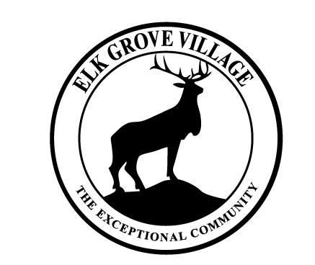

VILLAGE OF ELK GROVE VILLAGE

JOB POSTING
ENGINEERING INTERN- COMMUNITY DEVELOPMENT

The Village of Elk Grove Village is seeking a second or third-year engineering student to assist the Community Development Department’s engineering staff during the summer of 2023.
Elk Grove Village is located in the Chicago suburbs, bordering O’Hare International Airport, and is home to 33,000 residents and 3,600 businesses that make up the largest business park in the Midwest. Interested applicants should be enrolled in a Civil Engineering curriculum. Drafting and surveying experience is a plus but not required.
This paid position will provide the successful applicant with an excellent opportunity to observe and participate in various Civil Engineering projects.
Duties of the Engineering Intern include, but are not limited to:
- Residential permit inspections for sidewalks, patios, driveways, water main pressure tests, and small construction projects.
- Assisting the Staff Engineer with construction plan reviews.
- Various inspections for drainage and utility restorations.
- Assisting with survey work.
- Various other duties, as assigned.

SALARY RANGE: $16.71/Hour HOURS OF WORK: 40 Hours/Week
OPENING DATE: February 22, 2023 CLOSING DATE: March, 17 2023

Applicants must submit the online employment application at www.elkgrove.org by Friday, March 17, 2023. Attach your cover letter, resume, and references, as indicated. Proof may be required for qualifications.

All other inquiries should be directed to the Office of Human Resources: 901 Wellington Avenue, Elk Grove Village, Illinois, 60007.

Email: humanresources@elkgrove.org Phone: (847) 357-4020

