NOMINATION FORM

SUSTAINABILITY IN CIVIL ENGINEERING

ACHIEVEMENT AWARD
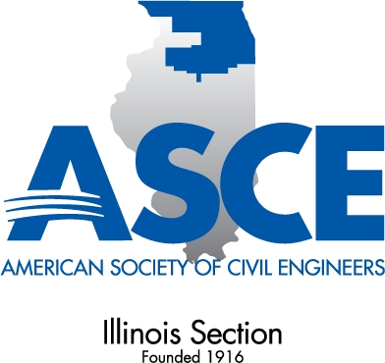
This award is presented to Civil Engineering Projects within the ASCE Illinois Section that exhibit the greatest innovation in sustainability. The Award Rules are:
      - The award may be made annually to a civil engineering project in recognition of creativity in the form of innovative sustainability. Projects may be any that demonstrate innovation in sustainability.
      - To be eligible for consideration, projects must, first and foremost, demonstrate adherence to the principles of economic, social and environmental sustainability. Projects constructed in the six-year period preceding the year of award are eligible.
      - The criteria used to evaluate projects are:
        - The extent to which innovative design or construction methods improve economic, social and environmental sustainability;
        - The promise shown by the innovation to extend future developments in sustainability;
        - The degree to which the project extends public understanding of sustainability in construction.
- The recipient of this award shall be recommended by the Illinois Section Sustainability Committee to the Awards Committee and Illinois Section Board for final approval. Entries not selected to receive the award may be carried over for reconsideration in the following year provided they remain eligible within the six-year completion period.

Submittal Requirements

- A completed nomination form
- A nominator’s statement describing how the project exemplifies the economic, social and environmental principles of sustainability, the merits and title of the project, a clear description of the innovation in sustainability, the anticipated advantages to be obtained, and a statement of how the sustainable project met the client’s needs.
- Three to six color photographs, including captions, depicting the project and its innovation in sustainability.
- Statement of support from project owner (if different from nominator).

Please mail one (1) original or e-mail a PDF of the award application no later than JULY 16, 2021 to:

Sarah Harbaugh
ISASCE
35W749 Bluff Drive
St. Charles, IL 60175
Phone: 630-443-8145
Email: illinoissection@isasce.org

Sustainability in Civil Engineering Achievement Award
NOMINATION INFORMATION

Name of Project: ________________________________________________________________

Name of Owner: ________________________________________________________________

Location of Project: ______________________________________________________________

By entering your project, you are attesting that it meets the following eligibility:

- Projects that demonstrate innovation in sustainability are eligible.
Project demonstrates innovation in sustainability.

- Projects constructed in the six-year period preceding the year of award are eligible.
Project open date _________________________________.

Nominator’s name: ________________________ Signature: ____________________________

Telephone number: ______________________ Email: ________________________________

Describe the nominator’s role:
Nominator only or Active in the project

If active in the project, describe activity:
I. ABOUT THE PROJECT

- Describe the extent to which innovative design or construction methods improve the economic, social and environmental sustainability. (500 words or less)

- Describe the promise shown by the innovation to promote, replicate and extend further developments in sustainability. (500 words or less)

- Describe the degree to which the project extends the public’s understanding of sustainability in engineering and construction. (500 words or less)

- Describe the sustainable aspects of the projects that met the client’s needs. (500 words or less)

II. PROJECT TEAM

Project owner’s name:
Owner’s representative:
Title:
Mailing address:
Phone number: |  |  |  |  | Email address:
Engineer of Record:
Mailing address:
Phone number: |  |  |  | Email address:
Primary Contractor:
Contact name:
Company name:
Mailing address:
Phone number: |  |  |  | Email address:

